Definition:

1. Process Control Block (PCB)

Each process is represented in the operating system by a process control block (PCB)—also called a task control block.

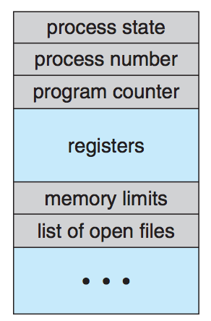

2. Hashed Page Tables

A common approach for handling address spaces larger than 32 bits is to use a hashed page table, with the hash value being the virtual page number. Each entry in the hash table contains a linked list of elements that hash to the same location (to handle collisions). Each element consists of three fields:

(1) the virtual page number

(2) the value of the mapped page frame

(3) a pointer to the next element in the linked list.

3. RAID

Using Redundant Array of Independent Disk to improve the reliability of data storage.

(a) RAID 0: non-redundant striping.

(b) RAID 1: mirrored disks.

(c) RAID 2: memory-style error-correcting codes.

(d) RAID 3: bit-interleaved parity.

(e) RAID 4: block-interleaved parity.

(f) RAID 5: block-interleaved distributed parity.

4. Process state (also list the states)

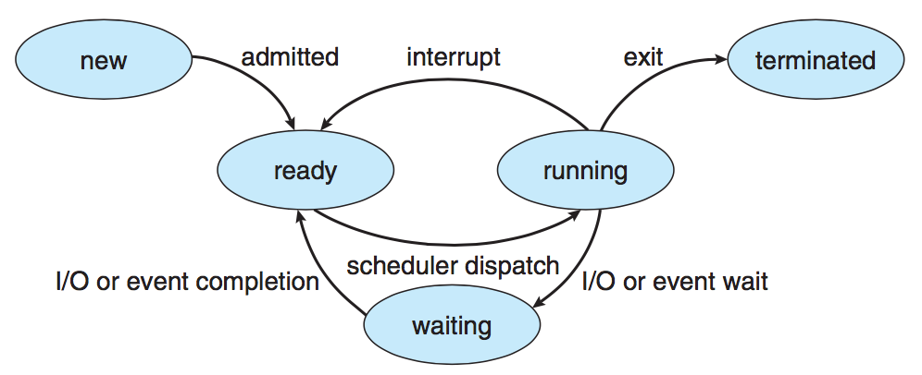

5. Principle of least privilege

A key, time-tested guiding principle for protection is the principle of least privilege. It dictates that programs, users, and even systems be given just enough privileges to perform their tasks.

6. Monitor

A high-level abstraction that provides a convenient and effective mechanism for process synchronization

8. Direct memory access (DMA)

Many computers avoid burdening the main CPU with PIO by offloading some of this work to a special-purpose processor called a direct-memory-access (DMA) controller. The DMA controller proceeds to operate the memory bus directly, placing addresses on the bus to perform transfers without the help of the main CPU.

9. File control block

A file control block (FCB) contains information about the file, including ownership, permissions, and location of the file contents.

10. Virtual memory

Virtual memory involves the separation of logical memory as perceived by users from physical memory. This separation allows an extremely large virtual memory to be provided for programmers when only a smaller physical memory is available (Figure 9.1). Virtual memory makes the task of programming much easier, because the programmer no longer needs to worry about the amount of physical memory available; she can concentrate instead on the problem to be programmed.

11. Deadlock

In a multiprogramming environment, several processes may compete for a finite number of resources. A process requests resources; if the resources are not available at that time, the process enters a waiting state. Sometimes, a waiting process is never again able to change state, because the resources it has requested are held by other waiting processes. This situation is called a deadlock.

12. Swap-space management

Swap-space management is another low-level task of the operating system. Virtual memory uses disk space as an extension of main memory.

13. Need-to-know principle

A process should be allowed to access only those resources for which it has authorization. Furthermore, at any time, a process should be able to access only those resources that it currently requires to complete its task. This second requirement, commonly referred to as the need-to-know principle, is useful in limiting the amount of damage a faulty process can cause in the system.

Computing:

* **Scheduling Algorithms**

Gantt chart

1. First- Come, First-Served (FCFS) Scheduling

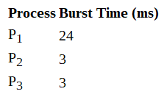

|  |  |  |
| --- | --- | --- |
| <p1,p2,p3> | waiting time | average waiting time |
| P1 | 0 | (0+24+27)/3=17 |
| P2 | 24 |
| P3 | 27 |

|  |  |  |
| --- | --- | --- |
| <p2,p3,p1> | waiting time | average waiting time |
| P2 | 0 | (0+3+6)/3=3 |
| P3 | 3 |
| P1 | 6 |

2. Shortest-Job-First (SJF) Scheduling

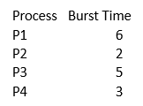

|  |  |  |
| --- | --- | --- |
| <p2,p4,p3,p1> | waiting time | average waiting time |
| P2 | 0 | (0+2+5+10)/4=3.75 |
| P4 | 2 |
| P3 | 5 |
| p1 | 10 |

3. Shortest-remaining-time-First

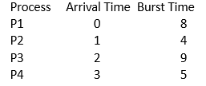

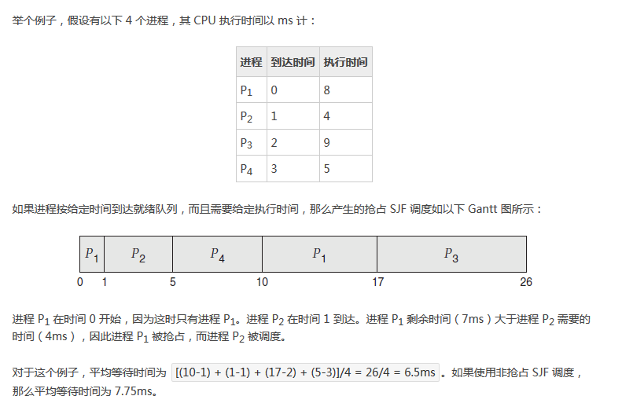

4. Priority Scheduling

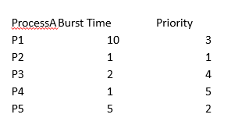

|  |  |  |  |
| --- | --- | --- | --- |
| <p2,p5,p1,p3,p4> | waiting time | burst time | average waiting time |
| p2 | 0 | 1 | (0+1+6+16+18)/5=8.2 |
| p5 | 1 | 5 |
| p1 | 6 | 10 |
| p3 | 16 | 2 |
| p4 | 18 | 5 |

5. Round Robin (RR)

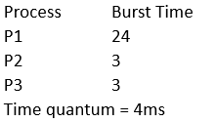

|  |  |  |  |
| --- | --- | --- | --- |
| process | burst time | time | rest time |
| P1 | 24 | 4 | P1: 20 |
| P2 | 3 | 7 | P2 finished |
| P3 | 3 | 10 | P3 finished |
| P1 | 20 | 14 | P1:16 |
| P1 | 16 | 18 | P1:12 |
| P1 | 12 | 22 | P1:8 |
| P1 | 8 | 26 | P1:4 |
| P1 | 4 | 30 | P1 finished |

Page Replacement



3 frames

1.First-In-First-Out (FIFO) Algorithm

|  |  |  |  |  |  |  |  |  |  |  |  |  |  |  |  |  |  |  |  |  |  |
| --- | --- | --- | --- | --- | --- | --- | --- | --- | --- | --- | --- | --- | --- | --- | --- | --- | --- | --- | --- | --- | --- |
| 7 | 0 | 1 | 2 | 0 | 3 | 0 | 4 | 2 | 3 | 0 | 3 | 0 | 3 | 2 | 1 | 2 | 0 | 1 | 7 | 0 | 1 |
| 7 | 7 | 7 | 2 |  | 2 | 2 | 4 | 4 | 4 | 0 |  |  |  |  | 0 | 0 |  |  | 7 | 7 | 7 |
|  | 0 | 0 | 0 |  | 3 | 3 | 3 | 2 | 2 | 2 |  |  |  |  | 1 | 1 |  |  | 1 | 0 | 0 |
|  |  | 1 | 1 |  | 1 | 0 | 0 | 0 | 3 | 3 |  |  |  |  | 3 | 2 |  |  | 2 | 2 | 1 |

Page faults=15

2. Optimal Page Replacement

|  |  |  |  |  |  |  |  |  |  |  |  |  |  |  |  |  |  |  |  |  |  |
| --- | --- | --- | --- | --- | --- | --- | --- | --- | --- | --- | --- | --- | --- | --- | --- | --- | --- | --- | --- | --- | --- |
| 7 | 0 | 1 | 2 | 0 | 3 | 0 | 4 | 2 | 3 | 0 | 3 | 0 | 3 | 2 | 1 | 2 | 0 | 1 | 7 | 0 | 1 |
| 7 | 7 | 7 | 2 |  | 2 |  | 2 |  |  | 2 |  |  |  |  | 2 |  |  |  | 7 |  |  |
|  | 0 | 0 | 0 |  | 0 |  | 4 |  |  | 0 |  |  |  |  | 0 |  |  |  | 0 |  |  |
|  |  | 1 | 1 |  | 3 |  | 3 |  |  | 3 |  |  |  |  | 1 |  |  |  | 1 |  |  |

Page faults=9

3. Least Recently Used (LRU) Algorithm

|  |  |  |  |  |  |  |  |  |  |  |  |  |  |  |  |  |  |  |  |  |  |
| --- | --- | --- | --- | --- | --- | --- | --- | --- | --- | --- | --- | --- | --- | --- | --- | --- | --- | --- | --- | --- | --- |
| 7 | 0 | 1 | 2 | 0 | 3 | 0 | 4 | 2 | 3 | 0 | 3 | 0 | 3 | 2 | 1 | 2 | 0 | 1 | 7 | 0 | 1 |
| 7 | 7 | 7 | 2 |  | 2 |  | 4 | 4 | 4 | 0 |  |  |  |  | 1 |  | 1 |  | 1 |  |  |
|  | 0 | 0 | 0 |  | 0 |  | 0 | 0 | 2 | 2 |  |  |  |  | 2 |  | 2 |  | 7 |  |  |
|  |  | 1 | 1 |  | 3 |  | 3 | 2 | 3 | 3 |  |  |  |  | 3 |  | 0 |  | 0 |  |  |

Page faults=12

**Abbreviation**

DMA: Direct Memory Access

CLI: command-line interface

GUI: Graphical User Interface

API: Application Programming Interface

CIA: confidentiality, integrity, availability

RBAC: Role-based Access Control

PCB: Process Control Block

IPC: Inter-Process Communication

FCFS: First- Come, First-Served Scheduling

SJF: Shortest-Job-First Scheduling

RR: Round Robin

LWP: light weight process

MMU: memory-management unit

TLB: Translation Look-Aside Buffer

LRU: least-recently-used algorithm

SMP: Symmetric multiprocessing

SSTF: shortest-seek-time-first

C-SCAN: circular SCAN

ECC: error-correcting code

SCSI: Small Computer System Interface

RAID: Redundant Array of Independent Disk

FCB: File Control Block

FAT: File Allocation Table